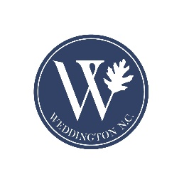
Solid Waste Billing – Frequently asked Questions

- When is the bill due? Due Date is 30 days from receipt of bill. The penalty and fee language at the top of the bill refers to property tax payments.

- Can I pay online or with a credit card? There is no opportunity for online or credit card payments for this initial bill, but future payments will be included in the tax bill and may be paid online. You can drop the payment in the mail or bring it to town hall. Feel free to use the drop box beside town hall if outside of office hours.

- Can I opt out? Currently, there is no option to opt out of the trash payment. The contract cost to the town is based on participation of all homes in Weddington, so all homes will be assessed the fee.

- What if I own vacant land and received a bill? If a property owner received a bill for vacant land, please email town staff to have the property removed from the billing.

- What if I sold my home and received a bill? Email town staff and we will bill the new owner.

For customer service issues, please contact Active Waste Solutions directly at 704-626-7400 or info@activewastesolutions.com

