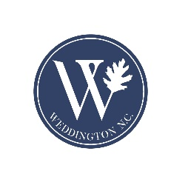

Election Date: Tuesday, November 7, 2023
The candidate filing period begins at Noon on July 7, 2023, and ends on July 21, 2023, at the Union County Board of Elections, 316-B East Windsor Street, Monroe, NC 28112.
On the Ballot: Mayor, District 2 and District 4 Councilmembers, and Referendum for Amending the Town Charter to change form of government from Council-Mayor to Council-Manager.

For more information on the charter amendment, please visit Council Manager Form of Government | Town of Weddington

